粒子物理学术报告

时间：2014年5月29日(星期四)上午10:30-11:30

地点：理科楼三楼物理系报告厅

Title: "Search for Dip at the LHC"

Abstract:

The traditional method searching for new physics beyond the Standard Model has been focused on bumps or resonances. In this talk, I want to propose a new type of signatures at the Large Hadron Collider with the new particle as a dip around its mass. I will categorize all potential dip particles for arbitrary spins and discuss the experimental search strategies.

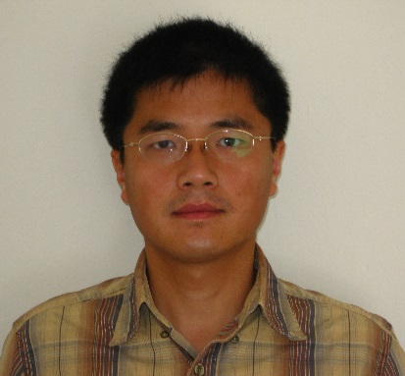Speaker: Yang Bai （白杨）

Department of Physics at University of Wisconsin-Madison

Dr. Yang Bai is an assistant professor in the Department of Physics at University of Wisconsin-Madison. He got his Bachelor of Science degree from USTC in 2002 and Ph.D. degree from Yale University in 2007. He worked as a research associate at the Fermi from 2007-2010 and SLAC from 2010-2012 and joined University of Wisconsin-Madison as a faculty member in 2012. His research interest is physics beyond the Standard Model including model building, collider physics and dark matter phenomenology.